**Cn Project Report (before error handling)**

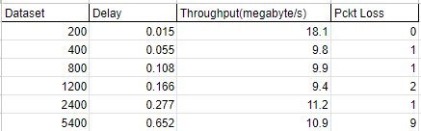

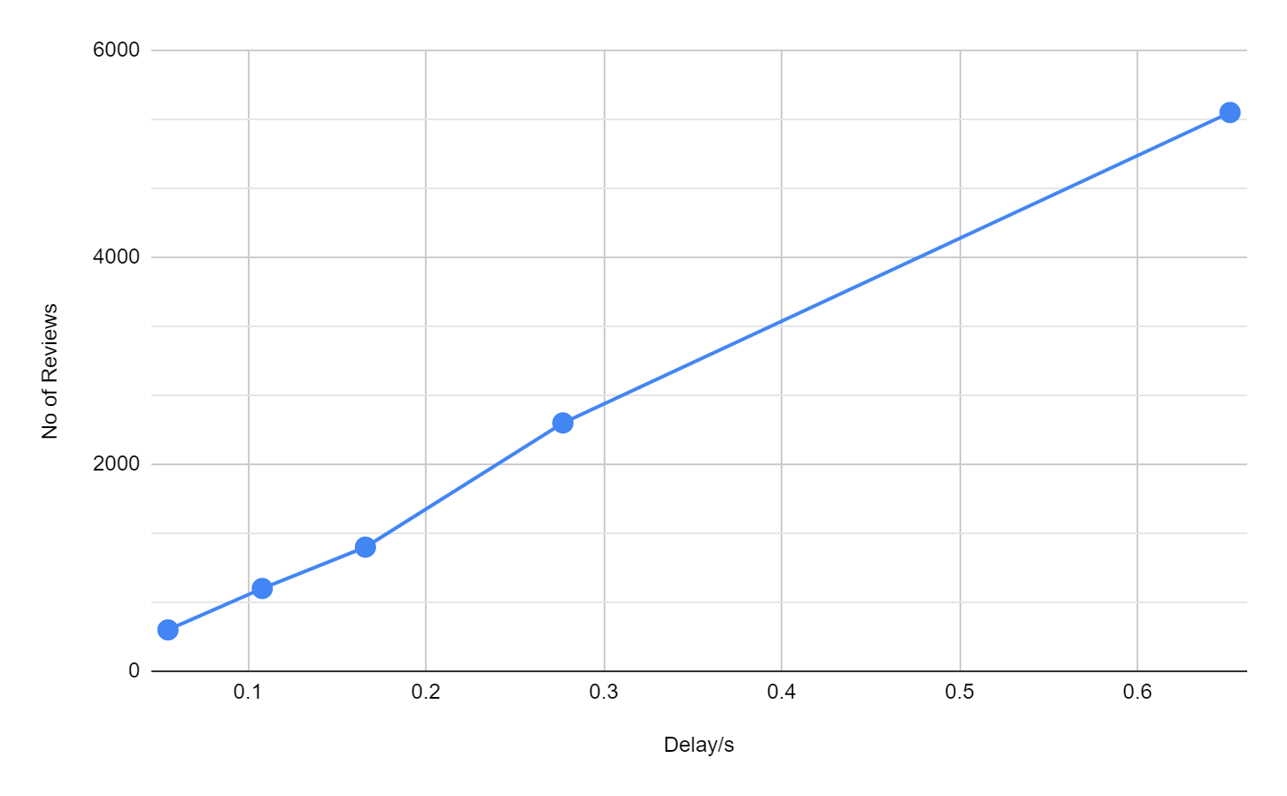

There is approximately a linear relation between the dataset and Delay by the program.